

**AFTER HOURS**

Blood-Borne Pathogen Exposure Flow Sheet

**For use:** weekends, holidays, and Monday-Friday 4 p.m. to 6 a.m.

**EXPOSED EMPLOYEE DOES 1, 2, 3**

Needle stick: Immediately wash with soap and water; remove foreign material.

• Mucous membrane exposure (splash to eyes, mouth): Irrigate with NS x 15 min.

Call house supervisor through CHLA operator to get help and an exposure packet.

• Do not let the source patient be discharged until source labs are drawn or source refuses consent.

After all steps are completed, the exposed employee should follow the advice of the on-call Clinical Allergy/Immunology doctor and follow up with Employee Health Services (EHS) on the next business day. Bring the packet provided by the house supervisor when you go to EHS.

**3**

**HOUSE SUPERVISOR DOES 4**

* Assign a nurse guide to help the exposed employee through the process.

**4**

* Email the data and notification to [EmployeeHealth@chla.usc.edu](mailto:EmployeeHealth@chla.usc.edu) (include name and phone number of exposed employee, special identifier of exposed employee, name and MR number of source* and name and phone number of mother of source if applicable).

*If the source is not known, the house supervisor or delegated nurse guide calls the on-call clinical Allergy/Immunology physician to discuss the circumstances of the exposure and will skip to step 12 below. End of protocol.

*If the source is known, the nurse guide follows steps 5, 6, 7, 8 and 9 below and the rest of the protocol is followed.

**THE EMPLOYEE AND ASSIGNED NURSE GUIDE DO 5, 6, 7, 8, 9**

Have the exposed employee sign the Request for Evaluation of Blood/Body Fluid Exposure form. Then call the resident, doctor or nurse practitioner on call for the source patient (the medical person who is treating the patient who is the source of contaminated body fluid).

**5**

Fill out all request forms (SOURCE, EMPLOYEE, and MOTHER OF SOURCE if needed) and collect labs.

**6• SOURCE LABS**

Complete SOURCE – Employee Health Exposure Testing Laboratory Request Form by entering the following:

Source Demographics

Name of the source of contaminated blood

Source Date of birth

Source MR#

Date

Use “EHS Source Blood-Borne Pathogen Exposure Panel” careset when entering in KIDS.

Labs needed: HIV rapid, HBc Ab, HBs Ag, HCVAb, ALT, AST

Collect labs from mother of source if source patient is less than 5 months old.

**7**

# MOTHER OF SOURCE LABS

* + Complete MOTHER of SOURCE – Employee Health Exposure Testing Laboratory Request Form by entering the demographics of the mother of source.
  + Use “EHS Mother of Source Blood-Borne Pathogen Exposure Panel” careset when entering in KIDS. Brian Kutsunai, MD (EHS medical director), is the ordering physician.
* EHS will assign MR# and place official order in KIDS on next business workday.

**(CONTINUED)**

**COLLECT EXPOSED EMPLOYEE’S LABS**

**8**o Complete EMPLOYEE – Employee Health Exposure Testing Laboratory Request Form for employee labs. **Use the four-letter code in**

**front of the packet for IDV. Do NOT put the employee’s name on the requisition.**

o Take the completed requisition and labeled blood to the lab, but do not try to put an order in KIDS.

EHS will place the official order in KIDS on the next business workday.

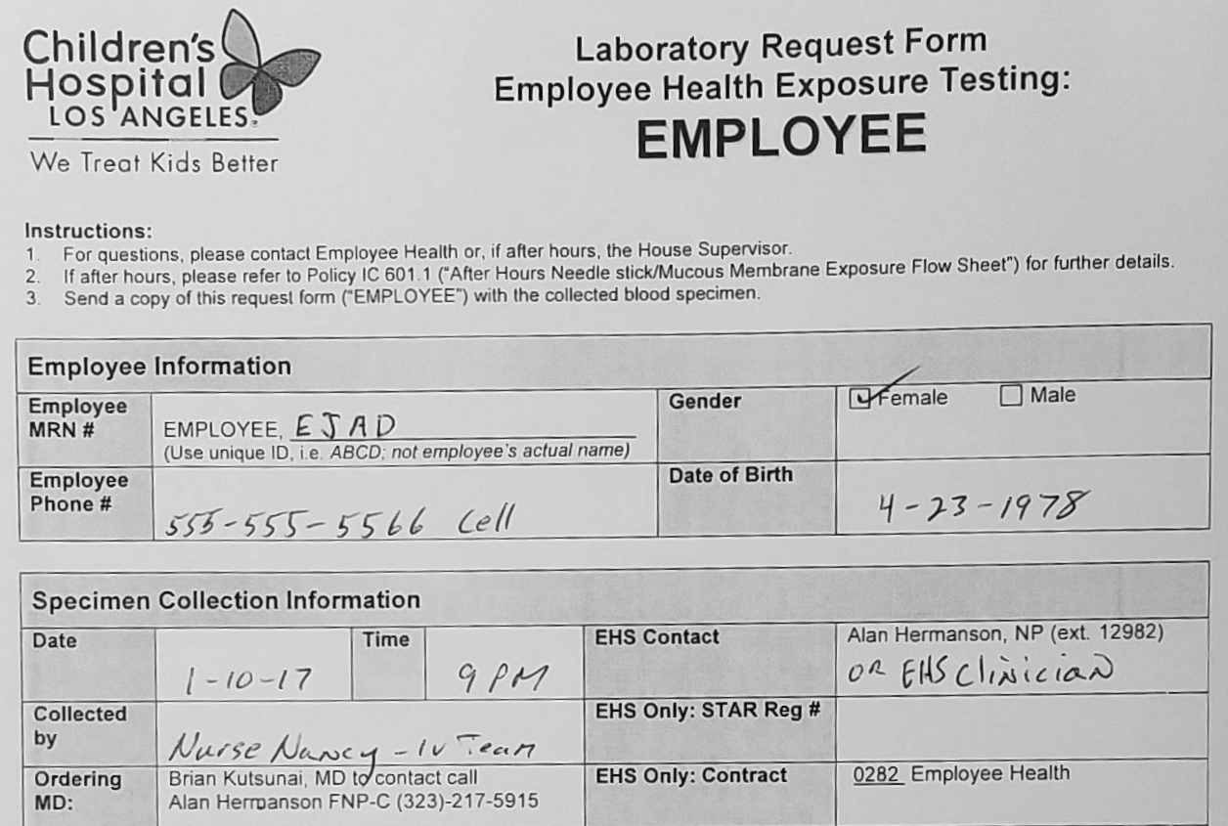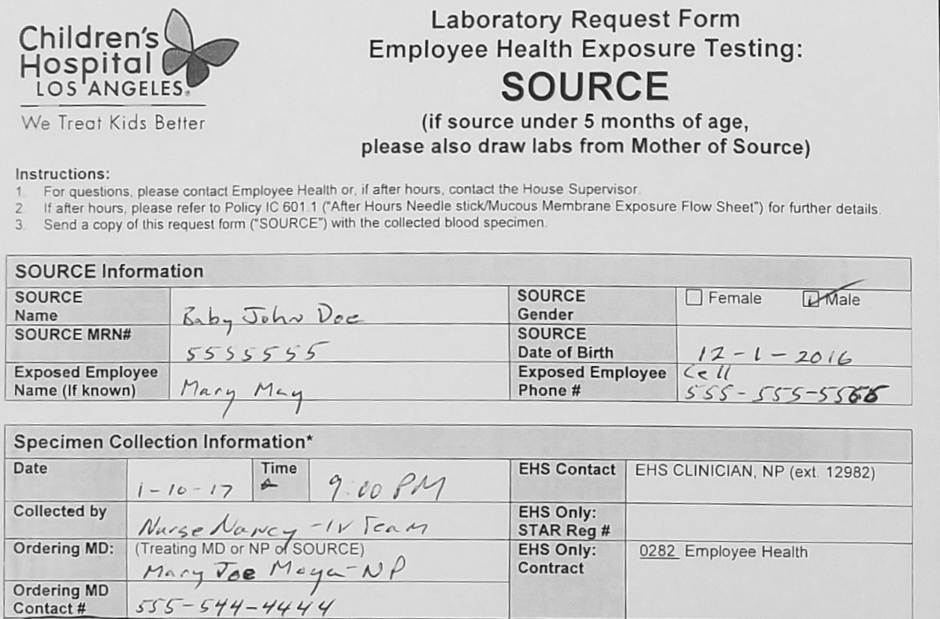

**Example of filled out forms for source, exposed employee (EE) and mother of source (MOS) lab requisitions:**

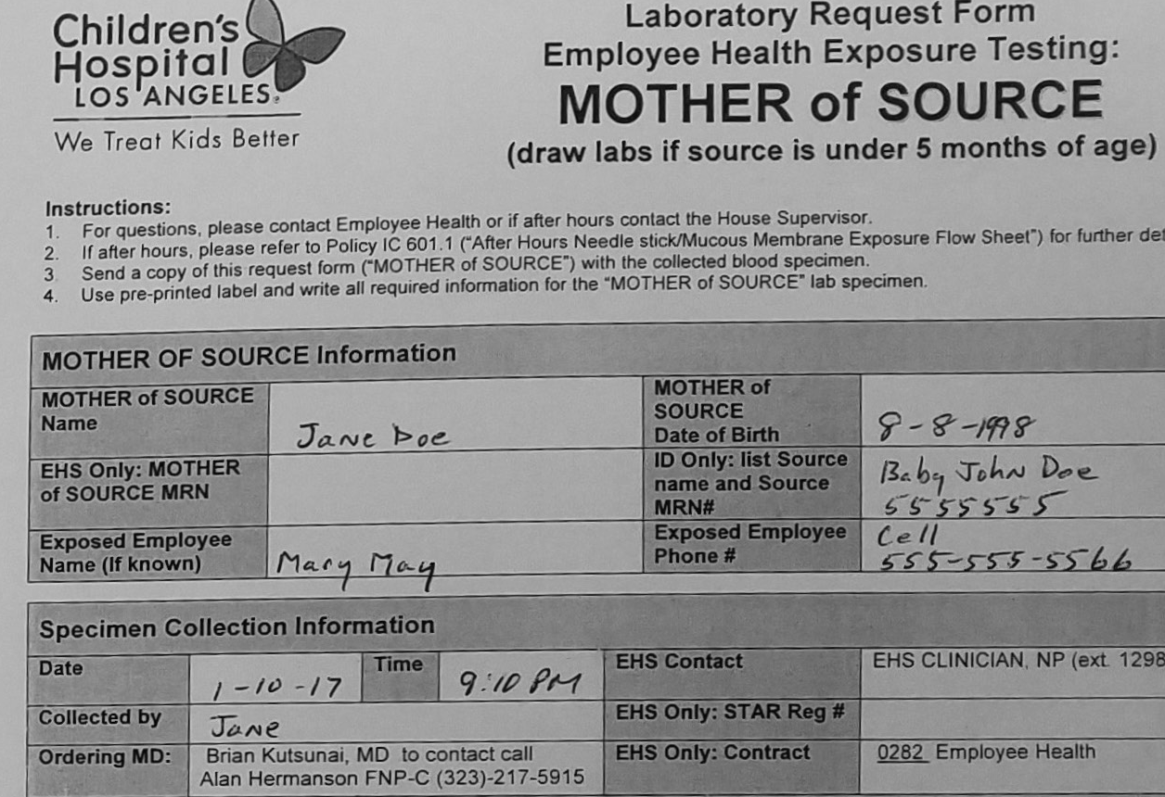

# Forms:

* 1. “EMPLOYEE – Employee Health Exposure Testing Laboratory Request Form”: White copy to lab with employee’s specimen; yellow copy to EHS.
  2. “SOURCE – Employee Health Exposure Testing Laboratory Request Form”: White copy to lab with specimen.
  3. “MOTHER OF SOURCE – Employee Health Exposure Testing Laboratory Request Form”: White copy to labs with specimen, yellow copy to EHS (not needed if source age is greater than 5 months).
  4. Fill out the top portion of Report of the “Employee & Volunteer Accident/Injury form” including a description of how the incident occurred, and place all copies in the packet for the Employee to take to EHS on the next business day.

For blood draw, call the Vascular Access team, or any available nurse can draw. Be sure the nurse who draws enters his or her KIDS

**9**ID, time lab drawn, and date.

Collect labs. Be sure to attach the preprinted labels to tubes and include the lab requisition forms.

**UNIT TREATING PHYSICIAN OR NURSE PRACTIONER DOES 10**

* Order labs needed on the source patient (your patient). Order under your name.

**10**

* Obtain and note verbal consent for HIV from source and from the exposed employee (consent form to be kept in packet when taken to EHS). Note source consent was obtained in the source medical record.
* Review stat labs and call the Clinical Allergy/Immunology doctor on call only if the source is unknown or source rapid HIV is positive.
* Provide “Dear CHLA Healthcare Worker” information sheet to exposed employee if source rapid HIV is negative.
* Do not let the source patient leave until labs are drawn or permission is denied.

Brian Kutsunai, MD (EHS medical director), should be listed as the ordering physician. The unit-treating physician or nurse practitioner will ultimately need to learn all source patient results, inform the source patient and follow up on source patient results.

**LAB DOES 11**

Lab will verbally report all positive rapid HIV results to the clinical Allergy/Immunology doctor on call and verbally report positive source rapid HIV results to the resident, physician or nurse practitioner caring for the source patient. Make all results available to EHS.

**11**

**CLINICAL ALLERGY/IMMUNOLOGY DOCTOR ON CALL DOES 12**

* Determine if prophylaxis PEP is required.

**12**

* Counsel employee.
* Instruct employee on how to take meds if offered and where to obtain them.
* Call prescription into inpatient pharmacy if treatment needed.
* Fill out a record of the call and forward to EHS via inter- office mail.